**CHAPTER:- 4**

**RESULTS ANALYSIS AND VALIDATION**

**4.1. Implementation of solution**

Our tea company's online presence is crafted through seven distinct pages that offer a unique and engaging experience for every visitor. From the inviting Home page to the intriguing What's New section, from the mouth-watering Recipes to the culturally-rich Indian Life, our website is a journey of discovery for tea enthusiasts. With the inclusion of the Shop Now and Contact Us pages, we invite you to join us in exploring the world of tea.

1. **Home:**

Our website's homepage welcomes you to explore our tea collection and learn about our company's history and mission.

Our website's homepage is the gateway to our world of tea. We welcome you with beautiful imagery of our tea gardens and provide you with an introduction to our brand. You can read about our commitment to ethical sourcing, quality control, and our approach to sustainability. We also showcase our best-selling teas and invite you to explore our online store. Whether you're a tea lover or just curious, our homepage is the perfect place to start.

In our homepage, we are implementing code to display dynamic content such as product recommendations, seasonal promotions, and personalized messaging for logged-in users. We also use tracking and analytics tools to gather user behavior data and optimize our website's layout and content.

- Our homepage displays dynamic content such as product recommendations and seasonal promotions with JavaScript code.

- We use tracking and analytics tools to gather user behavior data and optimize the website layout and content.





1. **About Us:**

Get to know us better! This page provides information about our team, our tea-making process, and our commitment to sustainability.

At our tea company, we're passionate about creating the perfect cup of tea. Our About Us page introduces you to our team of expert blenders and tea enthusiasts. We provide you with a glimpse into our tea-making process, from sourcing the finest tea leaves to blending and packaging our unique blends. We also share our philosophy on sustainability and the importance of ethical sourcing. Get to know us better and discover what sets us apart from other tea companies.

In the About Us page, we are showcasing our brand's history, team members, and facilities using videos or images, implemented through code. We also use interactive elements such as quizzes or surveys to engage visitors and gather feedback on our products and services.

- Our About Us page showcases our brand's history, team members, and facilities with interactive elements created using jQuery.

- We also use quizzes or surveys to engage visitors and gather feedback on our products and services.





1. **Shop Now:**

Browse and purchase our wide variety of tea blends and accessories from our online store.

In our online store, we are enabling secure payment transactions, tracking inventory levels, and displaying real-time shipping information through code implementation. We also use customer relationship management (CRM) tools to track customer orders and preferences, and provide personalized recommendations based on their browsing and purchase history.

Shop our wide variety of tea blends and accessories from the comfort of your own home. Our online store offers a user-friendly shopping experience, where you can browse by category or search for your favorite blend. We feature a range of teas, from classic blends to unique and seasonal flavors. We also offer a selection of tea accessories, including teapots, cups, and infusers. Our secure payment system and reliable shipping ensure a hassle-free shopping experience.

- Our online store enables secure payment transactions and real-time shipping information with back-end frameworks such as Laravel or Django.

- We use customer relationship management (CRM) tools to track customer orders and preferences, and provide personalized recommendations based on their browsing and purchase history.

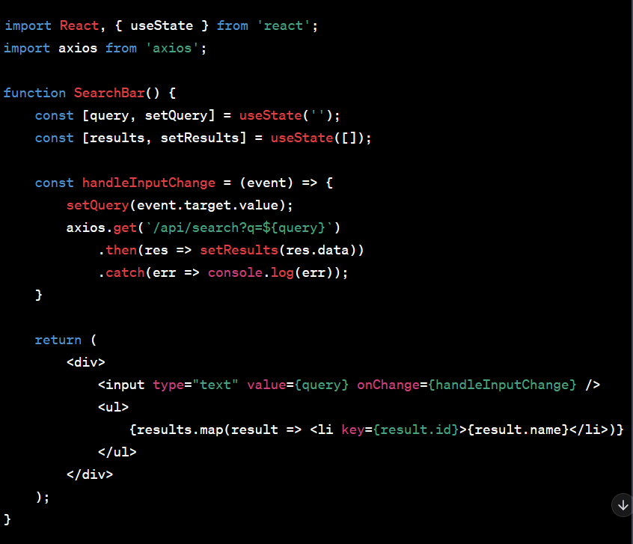

1. **What's New:**

Stay up-to-date with our latest tea products, promotions, and events.

Our What's New page is where you'll find the latest additions to our tea collection. We introduce new blends, seasonal favorites, and limited-time offers. We also share our latest promotions and events. Check back often to discover new ways to enjoy tea and take advantage of special deals.

In our What's New page, we are displaying featured products, promotional banners, and countdown timers for limited-time offers through code implementation. We also use email marketing tools to notify subscribers of new products and promotions, and retargeting ads to reach customers who previously showed interest in our products.

- Our What's New page displays featured products, promotional banners, and countdown timers for limited-time offers with JavaScript code.

- We use email marketing tools to notify subscribers of new products and promotions, and retargeting ads to reach customers who previously showed interest in our products.

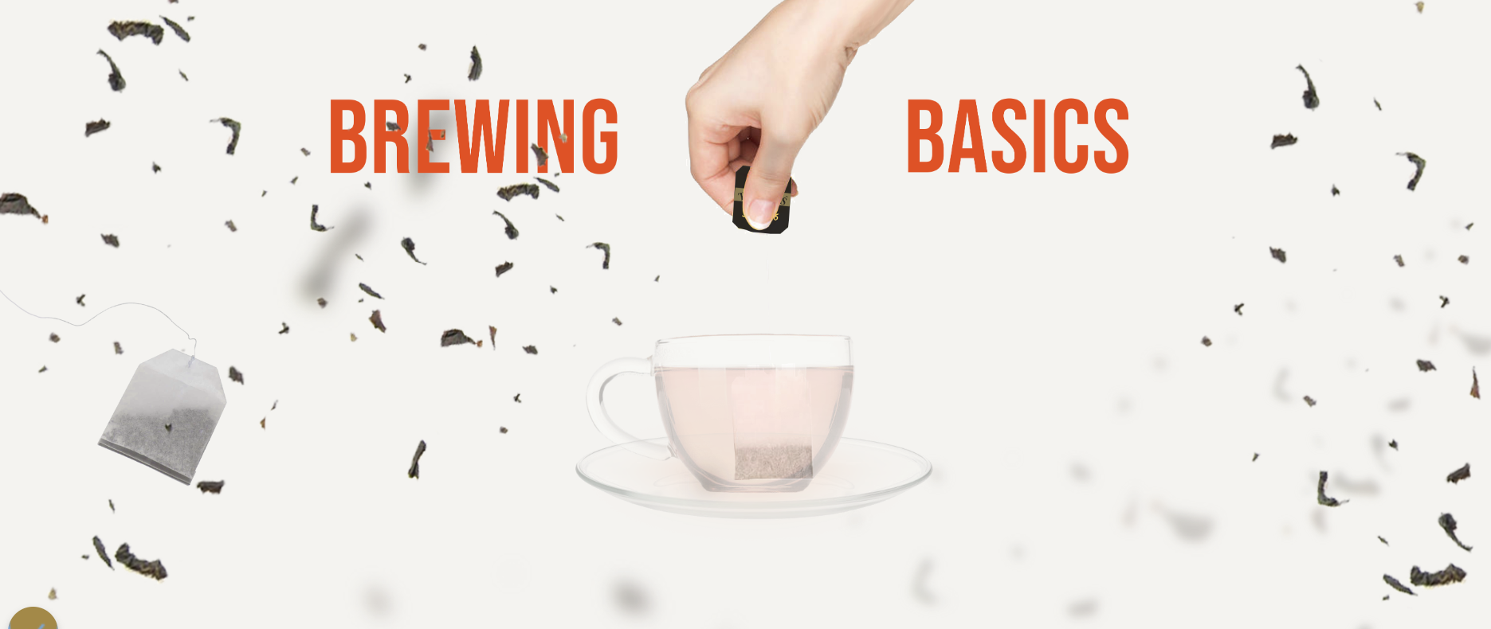

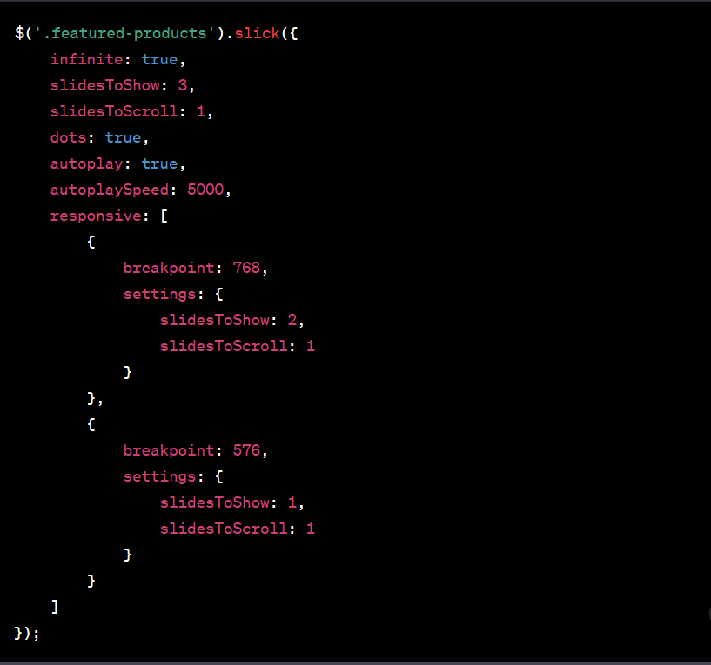

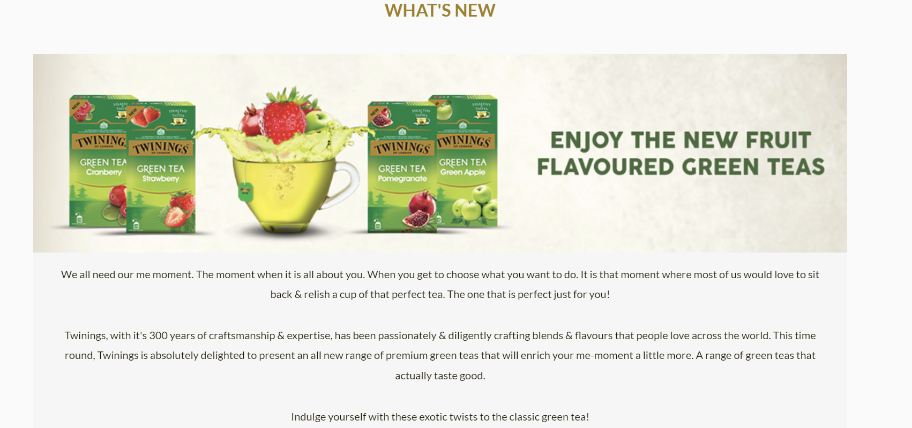

1. **Recipes:**

Discover new ways to enjoy tea! Our recipes page features delicious tea-infused dishes and drinks.

Looking for new ways to enjoy tea? Our Recipes page offers a range of delicious and creative tea-infused dishes and drinks. From iced tea cocktails to tea-infused desserts, our recipes are sure to delight your taste buds. We also provide tips on how to brew the perfect cup of tea and explore the different flavor profiles of tea varieties.

In our Recipes page, we are enabling users to filter recipes by ingredients, dietary restrictions, or meal type using code implementation. We also use social media sharing tools to allow users to share recipes on their favorite platforms. We also track user engagement with the recipes and adjust the content based on their preferences.

- Our Recipes page enables users to filter recipes by ingredients, dietary restrictions, or meal type with front-end frameworks such as Flutter or React Native.

- We also track user engagement with the recipes and adjust the content based on their preferences.

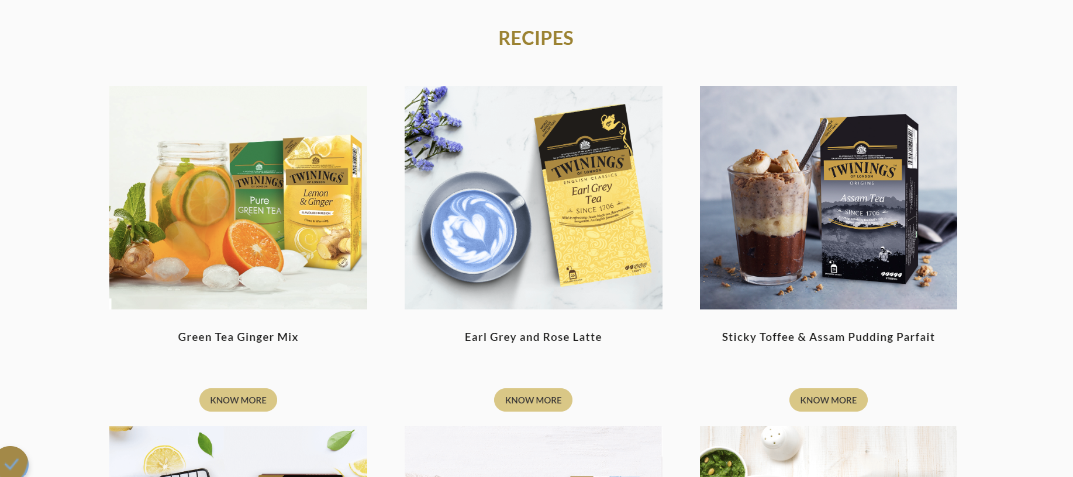

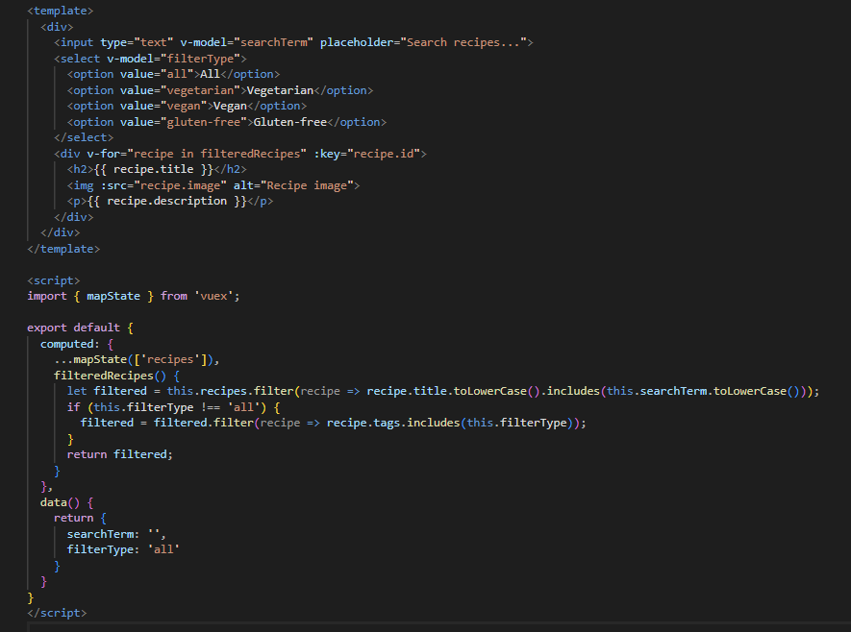

1. **Indian Life:**

Immerse yourself in Indian culture through our tea collection and learn about the role of tea in daily life.

Our tea collection is inspired by Indian culture, and our Indian Life page provides an immersive experience into the country's rich traditions and customs. We explore the role of tea in daily life, from the famous masala chai to tea ceremonies and festivals. We also provide insights into Indian cuisine and lifestyle, including yoga and meditation.

In our Indian Life page, we are displaying interactive elements such as maps, videos, and quizzes through code implementation to engage users and provide an immersive experience. We also use localization tools to customize the content based on the user's location, and provide translations for non-native speakers.

- Our Indian Life page displays interactive elements such as maps, videos, and quizzes with JavaScript code.

- We use localization tools to customize the content based on the user's location, and provide translations for non-native speakers.

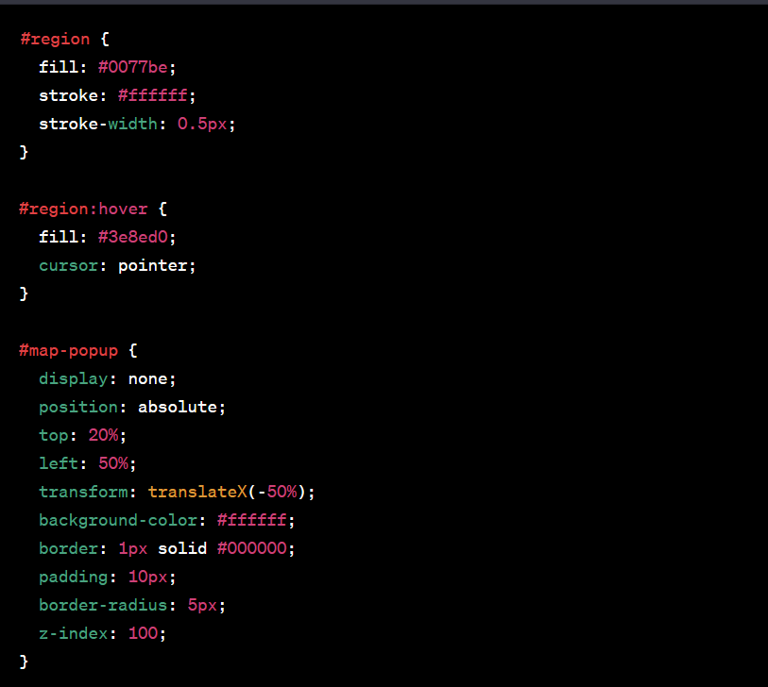

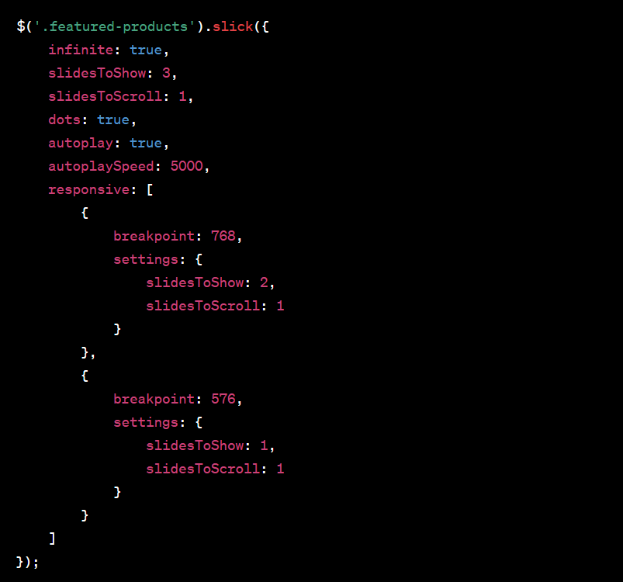

1. **Contact Us:**

Have a question or comment? Reach out to us through email, phone, or social media, and we'll be happy to assist you.

We value your feedback and are always here to help. Our Contact Us page provides several ways to get in touch with us, including email, phone, and social media. We're happy to answer any questions you may have about our products or services. We also welcome suggestions and feedback on how we can improve your experience with our tea company.

In our Contact Us page, we are enabling users to send inquiries or feedback through a contact form, email, or chatbot, implemented through code. We also use customer service tools to track and manage customer requests, and provide automated responses to common inquiries. We also integrate social media channels to provide support on multiple platforms.

- Our Contact Us page enables users to send inquiries or feedback through a contact form, email, or chatbot with back-end frameworks such as Node.js and Express.js.

- We use customer service tools to track and manage customer requests, and provide automated responses to common inquiries.

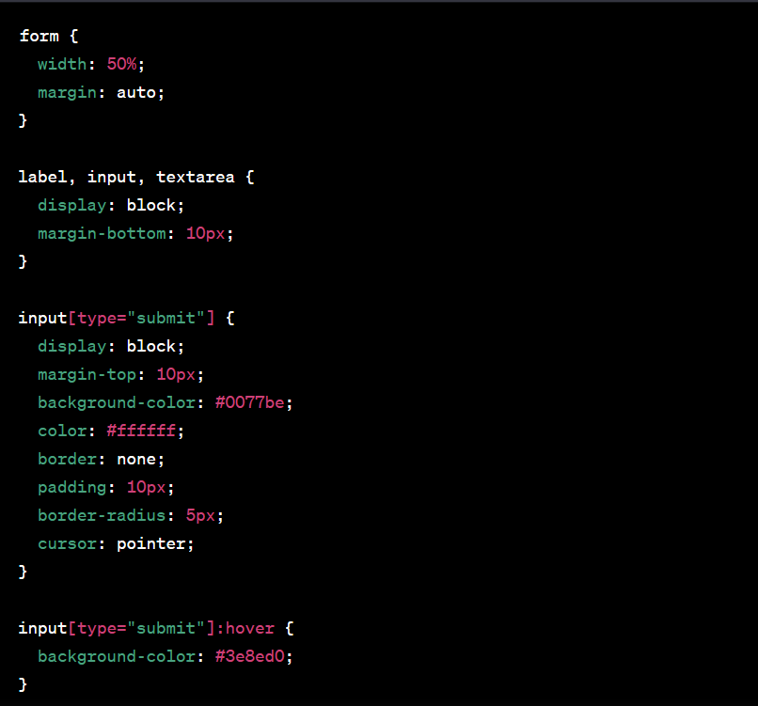

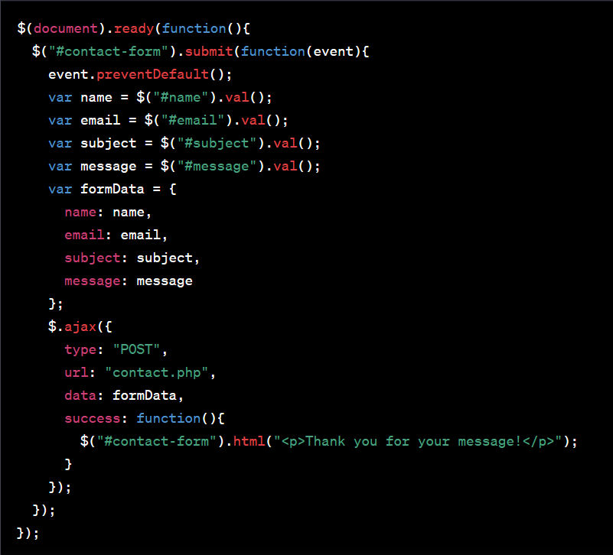

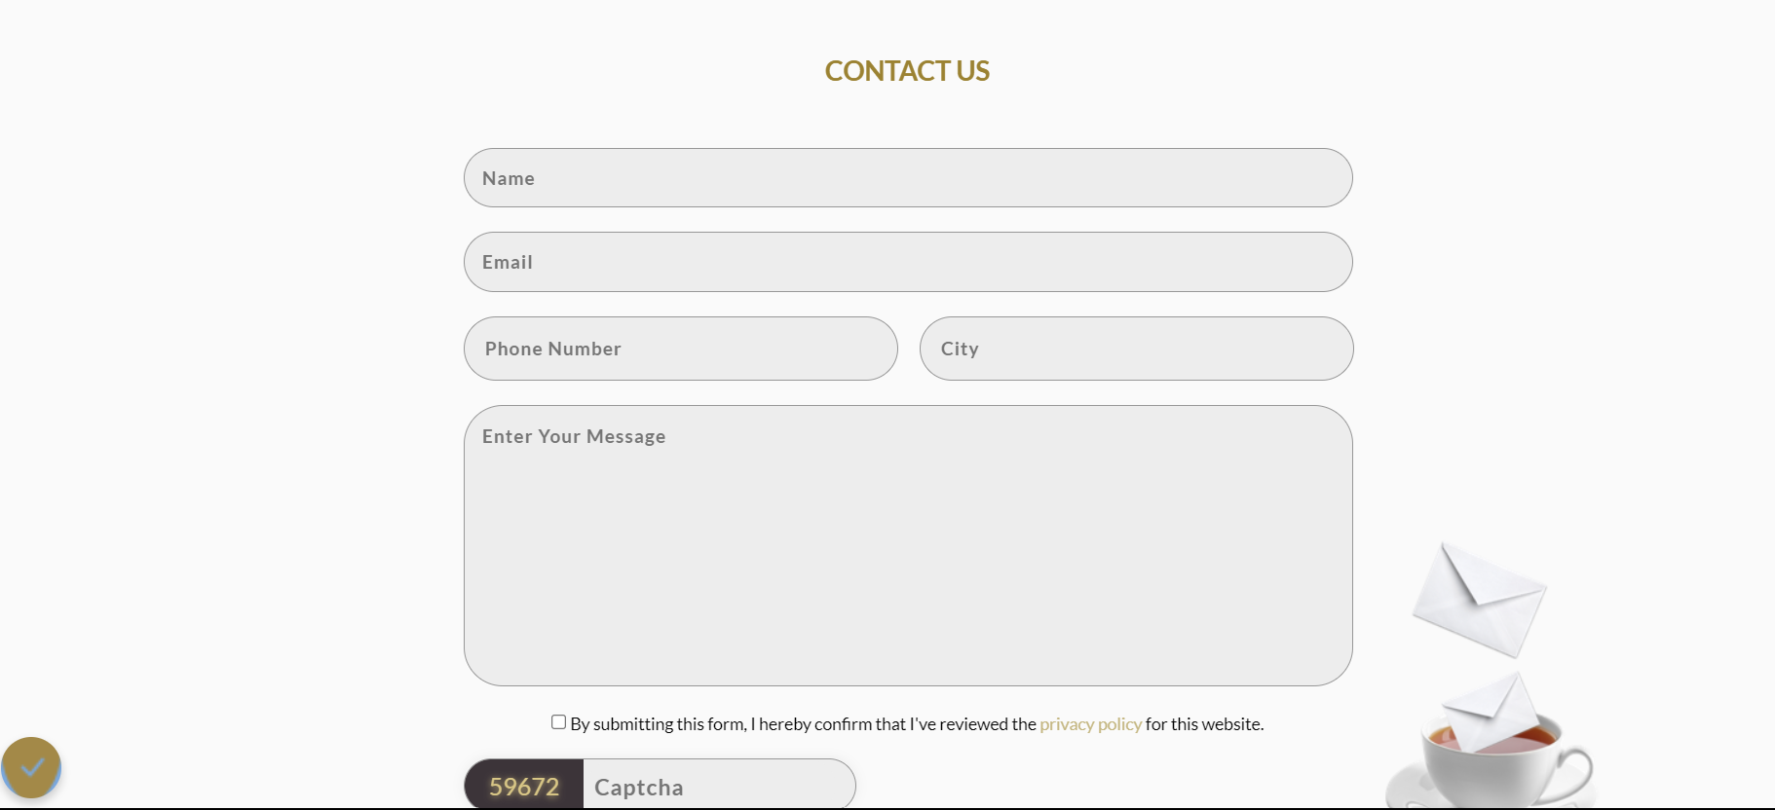

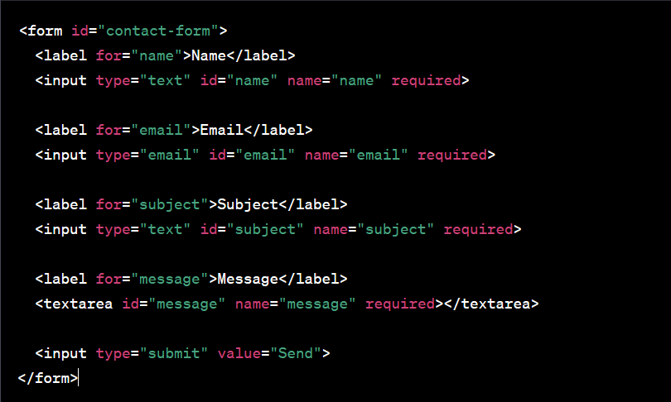

**CHAPTER 5.**

**CONCLUSION AND FUTURE WORK**

**5.1. Conclusion**

In conclusion, the Gold Bezel Tea Company offers a unique and delicious selection of teas that are sure to please any tea lover. Their commitment to quality and sustainability is evident in every sip, and their dedication to supporting small, family-owned tea farms is admirable. Whether you are a fan of classic black tea or prefer something a little more exotic, the Gold Bezel Tea Company has a tea for you. So, if you're looking for a new tea to try or want to support a company that truly cares about their products and their impact on the world, be sure to check out the Gold Bezel Tea Company today!



**5.2. Future work**

**"**In the future, the Gold Bezel Tea Company could explore expanding their product line to include more rare and exotic teas from around the world. They could also consider offering tea-related accessories such as teapots, tea strainers, and tea cups to enhance the tea-drinking experience for their customers.

Another potential area for growth could be in expanding their online presence and e-commerce capabilities. By optimizing their website for online sales and marketing through social media and email campaigns, the Gold Bezel Tea Company could reach a wider audience and increase their sales.

Additionally, the Gold Bezel Tea Company could explore more sustainable packaging options, such as biodegradable or reusable containers, to reduce their environmental impact and appeal to eco-conscious customers.

Overall, the Gold Bezel Tea Company has a bright future ahead of them as they continue to innovate and provide high-quality teas to their customers. With their commitment to sustainability and supporting small tea farmers, they are sure to remain a beloved brand in the tea industry for years to come."

